To: Village of Calumet Planning Commission and Ordinance Committee
From: Colleen Kobe, Planning Commission Chair
Date: Wednesday, July 08, 2020
Subject: Ordinance 153 Comments by Attorney Pat Greeley

Ordinance 153 Comments by Attorney Pat Greeley

These are the comments written by Attorney Pat Greeley regarding the Adult-Use Marihuana Ordinance.

Action Item: We need to decide whether to accept or reject each comment.

Colleen Kobe

Village of Calumet, Michigan
Ordinance No. 153
Regulation of Adult-Use Marihuana Establishments Ordinance
Final Version
for June 4, 2020, Public Hearing

  - May, 2020

Village of Calumet
Regulation of Adult-Use Marihuana Establishments Ordinance
Table of Contents
Section 1. TITLE 5
Section 2. Legislative Intent 5
Subdivision 1. Definitions 5
Subdivision 2. License Required for Marihuana Retail Establishment 6
Subdivision 3. Permitted Locations 7
Subdivision 4. Buffering Requirements 7
Subdivision 5. Marihuana Business Constraints 7
Subdivision 6. Application Process 10
Subdivision 7. Post-Application Restrictions 13
Section 3. Validity 25
Section 4. Date of passage 25
Section 5. Date of Effect 26

Table of Figures
Figure 1: Village of Calumet: Buffer Zones around Churches 19
Figure 2: Village of Calumet: Buffer Zones around buildings solely used as a single-family residence in a Commercial District 20
Figure 3: Village of Calumet: Buffer Zones measured from the borders of Calumet School Property 21
Figure 4: Village of Calumet: Buffer Zones around Drug and Alcohol Rehab Facilities 22
Figure 5: Village of Calumet: Buffer Zones for Churches, Schools, Rehab Facilities, and Private Residences in a Commercial District 23

Village of Calumet
Adult-Use Marihuana and Marihuana Microbusiness Ordinance
Houghton County, Michigan

TITLE
This Ordinance shall be known and may be cited as the Village of Calumet Regulation of Adult-Use Marihuana Establishments Ordinance.

Legislative Intent
It is the intent of this ordinance to authorize certain Marihuana Retailer or Microbusiness Establishments under the State of Michigan Regulation and Taxation of Marihuana Act, MCL § 333.27951 et seq. (the “Act”), in the Village and to provide for the adoption of reasonable restrictions to protect the public health, safety, security, and general welfare of the community at large; retain the characteristics of neighborhoods; and mitigate potential impacts on surrounding properties and persons. Nothing in this ordinance is intended to grant immunity from criminal or civil prosecution, or sanction for the cultivation, manufacture, possession, use, sale, or distribution of marihuana, in any form, that is not in compliance with Michigan law, including but not limited to the Act. As of the effective date of this ordinance, marihuana remains classified as a Schedule 1 controlled substance under the Federal Controlled Substances Act, 21 U.S.C.§ 801 et seq., which makes it unlawful to manufacture, distribute, or dispense marihuana. Nothing in this ordinance is intended to grant immunity from any criminal prosecution under federal laws. Marihuana Retailers and Microbusinesses shall be allowed in the C-1, General Commercial District, the C-2 Downtown Commercial District and the I-1 Light Industrial District subject to the following conditions and standards.

Definitions
Words used herein shall have the definitions as provided in the Act, as may be amended. To the extent that the following definitions conflict with the definitions found in the Act, the definitions found in the Act shall apply.
Conditional License means a certification provided by the Village of Calumet to an applicant for a Marihuana Retailer or Microbusiness License. This is issued prior to a Marihuana Retailer or Microbusiness License and allows the applicant to finalize the application for a state license.
Conditional Authorization means that the applicant has submitted a valid application for a Marihuana Retailer or Microbusiness License.
Marihuana means all parts of the plant of the genus cannabis, growing or not; the seeds of the plant; the resin extracted from any part of the plant; and every compound, manufacture, salt, derivative, mixture, or preparation of the plant or its seeds or resin, including marihuana concentrate and marihuana-infused products. For purposes of this act, marihuana does not include the mature stalks of the plant, fiber produced from the stalks, oil or cake made from seeds of the plant, any other compound, manufacture, salt, derivative, mixture, or preparation of the mature stalks, except the resin extracted from those stalks, fiber, oil, or cake, or any sterilized seed of the plant that is incapable of germination, industrial hemp, or any other ingredient combined with marihuana to prepare topical or oral administrations, food, drink, or other products.
Marihuana Microbusiness means a person licensed to cultivate not more than 150 marihuana plants; process and package marihuana; and sell or otherwise transfer marihuana to individuals who are 21 years of age or older or to a marihuana safety compliance facility, but not to other marihuana establishments.
Marihuana Retailer means a person or entity licensed to obtain marihuana from a marihuana establishment and to sell or otherwise transfer marihuana to marihuana establishments and to individuals who are twenty-one (21) years of age or older.
Marihuana Retailer License, local level: the final license granted by the Village of Calumet, under which the licensee may operate as a Marihuana Retailer or Microbusiness within the Village of Calumet.
Marihuana Retailer License, state level: a license pursuant to section 9 of the Act (MCL 333.27959) that allows a person to operate a marihuana establishment in the Village of Calumet.
Marihuana Microbusiness License means a license pursuant to Section 6 of the Act (MCL 333.27956) that allows a person to operate a marihuana microbusiness establishment in the Village of Calumet.
Person shall mean an individual, corporation, limited liability company, partnership of any type, trust or other legal entity.
Stakeholder shall mean a shareholder of a corporation, partner in a partnership, member of a limited liability company or individual of a sole proprietorship.
Village means the Village of Calumet.

License Required for Marihuana Retail Establishment
It shall be unlawful to operate as a Marihuana Retailer or Microbusiness without first obtaining a local Marihuana Retailer or Microbusiness License, pursuant to this ordinance, and having a validly issued license in good standing from the State of Michigan and having paid all applicable fees.
No person who is employed by the Village, acts as a consultant for the Village, or acts as an advisor to the Village and is involved in the implementation, administration or enforcement of this ordinance shall have an interest, directly or indirectly, in a Marihuana Retail Establishment.
It shall be unlawful to act as a marihuana event organizer, operate a marihuana event, or operate any of the following marihuana establishments or facilities, all as defined in the Act:
A. Marihuana Growers;
B. Marihuana Processors;
C. Marihuana Safety Compliance Facilities; or
D. Marihuana Secure Transports

Permitted Locations
All Village licenses for Marihuana Retailers and Marihuana Microbusinesses shall be issued for a specific physical location, which shall be designated as the licensed premises.

Buffering Requirements
At the time the initial application is submitted, no Marihuana Retailer or Microbusiness operated under this Section shall be within the specified feet of any of the following pre-existing uses:
A. Within any residentially-zoned district or area used for residential purposes;
B. Within tbd (500) feet of a building used solely as a single-family, primary residence or residence with a homestead exemption, located within the C-1, C2, or I-1 districts;
C. Within tbd (1,000) feet of any school, public or private licensed pre-school, or a public, private, or charter elementary, middle, junior high, or high school, vocational school, secondary school, community college, professional school, or other institution of higher education;
D. Within tbd (1,000) feet of any church, synagogue, mosque, or any house of worship; or
E. Within tbd (1,000) feet of any drug or alcohol rehab center.

Marihuana Business Constraints
1. There shall be no more than a grand total of three (3) Marihuana businesses operating in the Village at any time: that is, if the number of Marihuana Retailers is added to the number of Marihuana Microbusinesses, the total shall be three (3) or fewer.
2. There shall be no more than a grand total of three (3) Marihuana business licenses or conditional licenses operating in the Village at any time: that is, if the number of Marihuana Retailer or Microbusiness licenses or conditional licenses is added to the number of Marihuana Microbusiness licenses or conditional licenses, the total shall be three (3) or fewer.
3. Marihuana Retailers and Microbusinesses shall only operate after obtaining a Conditional Use Permit under Sections 8, 9, 10, and 13 of Ordinance No. 127.
4. Marihuana Retailers and Microbusinesses shall not operate without a Marihuana Retailer or Microbusiness License issued by the Village pursuant to the provisions of this ordinance.
5. Every applicant for a Marihuana Retailer or Microbusiness License to operate as a Marihuana Retailer, or for a Marihuana Microbusiness License to operate as a Marihuana Microbusiness, shall file an application with the Village Manager or other designee of the Village Council, upon a form provided by the Village. The application shall include:
A. The Village application fee in the amount determined by resolution of the council;
B. If the applicant is an individual, the applicant’s name; date of birth; Social Security number; physical address, including residential and any business addresses; copy of government-issued photo identification; email address; and one or more phone numbers, including emergency contact information;
C. If the applicant is not an individual, the names; dates of birth; physical addresses including residential and any business address; copy of government issued photo identifications; email addresses; and one or more phone numbers of each Stakeholder of the applicant, including designation of the highest ranking representative as an emergency contact person; contact information for the emergency contact person; articles of incorporation or organization; assumed name registration, if any; Internal Revenue Service tax identification confirmation letter; copy of the operating agreement of the applicant, if a limited liability company; copy of the partnership agreement, if a partnership names and addresses of the beneficiaries, if a trust; or a copy of the bylaws or shareholder agreement, if a corporation;
D. The name and address of the proposed marihuana establishment;
E. For the applicant, or for each Stakeholder of the applicant, an affirmation under oath as to whether they are at least twenty-one (21) years of age, and are not currently under indictment or have never been convicted of, pled guilty or nolo contendere to, or forfeited bail concerning any criminal offense under the laws of any jurisdiction, either felony or controlled-substance-related misdemeanor, not including traffic violation;
F. A signed release authorizing the Village to perform a criminal background check, for a fee established by the Village Council, to ascertain whether the applicant, each Stakeholder of the applicant, each managerial employee, and each employee of the applicant meet the criteria set forth in this ordinance. If the background check indicates a pending charge or conviction within the past ten (10) years for a controlled substance-related felony, the applicant shall not hire the prospective employee or agent without written permission from the Village Council;
G. The name, date of birth, physical address, copy of photo identification, and email address for any managerial employee or employee of the marihuana establishment, if other than the applicant;
H. An affirmation under oath as to whether the applicant or Stakeholder has ever applied for or has been granted any commercial license or certificate issued by a licensing authority in Michigan or any other jurisdiction that has been denied, restricted, suspended, revoked, or renewed and a statement describing the facts and circumstances concerning the application denial, restriction, suspension, revocation, or nonrenewal, including the licensing authority, the date each action was taken, and the reason for each action;
I. One of the following: (a) proof of ownership of the entire premises wherein the marihuana establishment is to be operated; or (b) written consent from the property owner for use of the premises in a manner requiring licensure under this ordinance along with a copy of the lease for the premises;
J. Proof of adequate premises liability and casualty insurance coverage in an amount not exceeding the requirements addressed in the Act or applicable Michigan laws, covering the marihuana establishment and naming the Village as an additional insured party, available for the payment of any damages arising out of an act or omission of the applicant or its Stakeholders, agents, employees, or subcontractors;
K. A description of the security plan for the marihuana establishment, including, but not limited to, any lighting, alarms, barriers, recording/monitoring devices, and/or security guard arrangements proposed for the facility and premises. The security plan must contain the specification details of each piece of security equipment;
L. A floor plan of the marihuana establishment, as well as a scale diagram illustrating the property upon which the marihuana establishment is to be operated;
M. An affidavit that neither the applicant nor any Stakeholder of the applicant is in default to the Village. Specifically, that the applicant or Stakeholder of the applicant has not failed to pay any property taxes, special assessments, fines, fees or other financial obligations to the Village;
N. An affidavit that the transfer of marihuana to and from the marihuana establishment shall be in compliance with the Act or other applicable Michigan laws;
O. A staffing plan;
P. Any proposed text or graphical materials to be shown on the exterior of the proposed marihuana establishment;
Q. A location area map of the marihuana establishment and surrounding area that identifies the relative locations and the distances from the closest exterior corner or exterior wall of the licensed marihuana establishment’s building, or distinct portion of a building having its own address (e.g.: suite or leased portion of a larger building encompassing the area to be inspected as a condition of the Conditional Use Permit) within which the licensed marihuana establishment may be licensed to do business, to the closest real property line of any of the uses listed in 4 above;
R. A facility sanitation plan to protect against any marihuana being ingested by any person or animal, indicating how the waste will be stored and disposed of, and how any marihuana will be rendered unusable upon disposal (disposal by onsite burning or introduction in the sewerage system is prohibited);
S. A copy of the Conditional Use Permit issued by the Planning Commission. A signed acknowledgment that the applicant is aware and understands that all matters related to marihuana growing, cultivation, possession, testing, safety compliance and transporting, are currently subject to state and federal laws, rules and regulations, and that the approval or granting of a Marihuana Retailer or Microbusiness License hereunder does not exonerate or Exculpate the applicant from abiding by the provisions and requirements and penalties associated with those laws, rules, and regulations, or exposure to any penalties associated therewith; and further, the applicant waives and forever releases any claim, demand, action, legal redress, or recourse against the Village, its elected and appointed officials, and its employees and agents for any claims, damages, liabilities, causes of action, damages, or attorney fees that the applicant may incur as a result of the violation by the applicant, its Stakeholders and agents of those laws, rules, and regulations; and
T. Any other information which may be required by the Village Manager.

Application Process
1. Upon receipt of an application, including the initial annual fee outlined below and any necessary documents required by the application, the application shall be time- and date-stamped by the Village Manager or other authorized Village official. The Village Manager or other authorized official shall review the application to determine whether the application is complete and whether the Marihuana Retailer or Microbusiness License is available within the number specified in this ordinance. The Village Manager shall use reasonable efforts to act to grant or deny a conditional authorization not later than thirty (30) days from the date the completed application is filed. Complete applications shall receive conditional authorization in consecutive time- and date-stamped order, subject to the availability of a Marihuana Retailer or Microbusiness License. The Village Manager shall notify the applicant of the denial or grant of the conditional authorization by first-class mail. Following the issuance of the conditional authorization, the application fee shall be nonrefundable. Should the Village Manager deny the conditional authorization, the applicant shall have fourteen (14) days from the mailing date of the denial to appeal by filing a notice of appeal with the Village Council. The Village Council may require additional information or act upon the appeal based upon the information supplied to the Village Manager. The Village Council shall hear the appeal at its next regular meeting, but not sooner than 7 days from the receipt of the appeal. Should the Village Council reverse the decision of the Village Manager, the Village Manager shall issue a conditional authorization. Should the Village Council affirm the Village Manager’s denial, the applicant shall have thirty (30) days to appeal the decision to the Circuit Court for Houghton County, State of Michigan.
2. Once the limit on the number of Marihuana Retailer or Microbusiness Licenses or conditional licenses for Marihuana Retailers or Microbusinesses is reached as provided herein, then any additional applications shall be held in consecutive time- and date-stamped order for future conditional authorization, and the Village Manager shall notify the applicant of this fact by first-class mail. Any applicant waiting for future conditional authorization may withdraw their submission prior to the issuance of a conditional authorization by written notice to the Village Manager at any time and receive a refund of the initial application fee submitted.
3. A “conditional authorization” means only that the applicant has submitted a valid application for a Marihuana Retailer or Microbusiness License. The applicant shall not locate or operate as a Marihuana Retailer or Microbusiness without first obtaining a Marihuana Retailer or Microbusiness License from the Village as provided herein, and all other permits and approvals as required by all other applicable ordinances and regulations of the Village, including a Conditional Use Permit under Section 9, 10 and 11 of Ordinance No. 127.
4. Applicants and licensees shall report any other change in the information required by this Section, to the Village within ten (10) days of the change. Fees shall be set by Council Resolution for any Stakeholder added after the original application is filed.
5. Upon receipt of the conditional authorization, the Village Manager shall submit the application to the Village Council for the issuing of a conditional license to the applicant. The Village Council shall review the conditionally authorized application at a public meeting. The Village Council may require the applicant and one or more Stakeholders to be present at the public meeting.
6. The Act requires that the Village establish a competitive process to select applicants who are best suited to operate in compliance with the Act and this ordinance, when more than one applicant has applied for an available Marihuana Retailer or Microbusiness License. The Village Council shall assess all applications referred to it by the Village Manager.
A. In its application deliberations, the Village Council shall assess each application in each of the following categories:
i. The applicant’s experience in operating other similarly licensed businesses;
ii. The applicant’s general business management experience;
iii. The applicant’s financial ability to operate as a Marihuana Retailer or Microbusiness and to purchase and maintain adequate liability and casualty insurance;
iv. Whether the applicant or Stakeholder is currently under indictment for or has been arrested for, or convicted of, pled guilty or nolo contendere to, or forfeited bail concerning, any relevant criminal offense under the laws of any jurisdiction, either felony or misdemeanor, not including traffic violations;
v. Whether the applicant or Stakeholder has been found guilty of a felony or misdemeanor of such nature that it may impair the ability of the applicant or Stakeholder to operate a licensed business in a safe and competent manner;
vi. Whether the applicant or Stakeholder has filed, or had filed against it, a proceeding for bankruptcy within the past seven (7) years;
vii. Whether the applicant or Stakeholder has been served with a complaint or other notice filed by any public body regarding payment of any tax required under federal, state, or local law that has been delinquent for one (1) or more years;
viii. Whether the applicant or Stakeholder has a history of non-compliance with any regulatory requirements in this state or any other jurisdiction;
ix. The impact that the establishment will have on surrounding area; and
x. Whether the applicant's site plan, floor plan, security plan, sanitation plan, and advertisement plan, adequately protect and promote the health, safety, well-being, and interests of the community.

B. The Village Council shall assess each application under the aforementioned categories and may issue a conditional license to the applicant if an applicant has satisfactorily met all requirements. An initial bidding period following the effective date of this ordinance shall be set by the Village Council by resolution. The Village Council shall review each conditionally authorized applicant who applies during the initial bidding period, before granting a conditional license. Following the close of the initial bidding period, the Village Council shall review each applicant as they receive conditional authorization. To the extent that multiple conditionally authorized applicants are pending at the same time, the Village Council shall use reasonable efforts to review the applications simultaneously.
7. All Marihuana Retailer or Microbusiness and Microbusiness Licenses and conditional licenses issued are contingent upon the State of Michigan issuing a license for the operation under state law. Within thirty (30) days of an applicant receiving the conditional license from the Village, the conditionally licensed applicant must submit proof to the Village Manager that the applicant has applied for a prequalification for a state operating license or has submitted a full application for such license. If the applicant fails to submit such proof, then such conditional license shall be cancelled by the Village Manager and the conditional license shall be available for other applicants.
8. If a conditionally licensed applicant is denied prequalification for a state operating license or is denied on full application for a state operating license, then such conditional license shall be canceled by the Village Manager and the conditional license shall be available. Applicant shall provide the Village notice of any denial of (1) prequalification for a state operating license or (2) full application for a state operating license.
9. Within thirty (30) days from the applicant submitting proof of obtaining a state operating license and completing all other required permits and approvals required by the Village, the Village shall approve the Marihuana Retailer or Microbusiness License. The applicant shall not locate or operate as a Marihuana Retailer or Microbusiness without first obtaining a Marihuana Retailer or Microbusiness License. A conditional license is not a Marihuana Retailer or Microbusiness License.
10. If a conditionally licensed applicant fails to obtain full authorization from the Village within one (1) year from the date of the conditional license, then such conditional license shall be canceled by the Village Manager.
11. Should the Village grant a Marihuana Retailer or Microbusiness License, the application fee shall be considered as the fee imposed for the first year the Marihuana Retailer or Microbusiness License or Microbusiness License is granted.

Post-Application Restrictions
1. A Marihuana Retailer or Microbusiness License issued under this ordinance is not transferable without the prior approval of the Village under the same terms and conditions required for the initial issuance of a license under this ordinance.
2. Information submitted to the Village in conjunction with an application for Marihuana Retailer or Microbusiness License, shall be subject to disclosure under the Michigan Freedom of Information Act, 1976 PA 442, MCL 15.231, et seq., unless an exemption exists.
3. A Marihuana Retailer or Microbusiness shall only be operated by the holder of a state operating license issued pursuant to the Act. Prior to operating as a Marihuana Retailer, the facility must comply with all zoning, construction, building or any other ordinance of the Village. The Marihuana Retailer or Microbusiness shall only be operated as long as it remains in compliance with Michigan law and all ordinance regulations. A Marihuana Retailer or Microbusiness shall consent to inspection of the Marihuana Retailer or Microbusiness by Village officials and/or by the Houghton County or State or Village of Calumet Police, upon reasonable notice, to verify compliance with this ordinance. If at any time a Marihuana Retailer or Microbusiness violates any Michigan law or ordinance, the Village Council may request that the state revoke or refrain from renewing the Marihuana Retailer or Microbusiness or Microbusiness’s state operating license. Once such state operating license is revoked or fails to be renewed, the Village Manager shall cancel the Marihuana Retailer or Microbusiness License or conditional license and a conditional license shall be available to the next application in consecutive time- and date-stamped order as provided herein.
4. It is hereby expressly declared that nothing in this ordinance shall be held or construed to give or grant to any Marihuana Retailer or Microbusiness a vested right, license, privilege or permit to continued authorization from the Village for operations within the Village. The Village expressly reserves the right to amend or repeal this ordinance in any way including, but not limited to, complete elimination of or reduction in the type and/or number of authorized Marihuana Retailers or Marihuana Microbusinesses.
5. Application and renewal fees for Marihuana Retailers and Marihuana Microbusinesses, if any, will be set by Council Resolution. If not set by Council Resolution, the default application fee and annual fee shall be the maximum permitted by the Act.
6. The following minimum standards shall apply to all Marihuana Retailers and Microbusinesses within the Village:
A. All activity related to a Marihuana Retailer or Microbusiness including, but not limited to, growing, shall be done indoors in a locked structure.
B. The Marihuana Retailer or Microbusiness shall be operated in compliance with the provisions of the Act, applicable Michigan law, and the general rules of the Department of Licensing and Regulatory Affairs (LARA) as they may be amended from time to time. It is the responsibility of the owner to be aware of changes in the Act, supporting regulations, or other Michigan Law. The Village bears no responsibility for failure of the owner to be unaware of changes in the Act, supporting regulations, or other Michigan Law.
C. The establishment shall be open, during regular business hours, to any representative of LARA state police officer, or Houghton County Officer, or Village of Calumet Code Enforcement Officer, and said individual(s) may enter the premises, offices, establishments, or other places of business of a licensee, for the following purposes:
i. To inspect and examine all premises of Marihuana Retailer or Microbusiness or Microbusiness;
ii. To inspect, examine, and audit relevant records of the licensee and, if the licensee or any employee fails to cooperate with an investigation, impound, seize, assume physical control of or summarily remove from the premises all books, ledgers, documents, writings, photocopies correspondence, records, and videotapes, including electronically stored records, money receptacles, or equipment in which the records are stored; and
iii. To investigate alleged violations of the Act, this ordinance and applicable Michigan law.
D. The Marihuana Retailer or Microbusiness shall be continuously monitored with a surveillance system that includes security cameras. The video recordings shall be maintained in a secure, offsite storage establishment for a period of fourteen (14) days on a continuing rolling basis and be available upon request of the State Police, or the Houghton County or Village of Calumet Police Departments. The storage establishment shall not be used for any other commercial purpose.
E. Smoking, inhalation, or consumption of marihuana shall not be allowed on the site of the Marihuana Retailer or Microbusiness or Microbusiness.
F. All marihuana shall be contained within an enclosed, secure area;
G. All persons working in direct contact with marihuana shall conform to acceptable hygienic practices while on duty, including, but not limited to:
i. Maintaining adequate personal cleanliness;
ii. Washing hands thoroughly in adequate hand-washing areas before starting work and at any other time when their hands may have become soiled or contaminated; and
iii. Refraining from having direct contact with marihuana if the person has or may have an illness, open lesion, including boils, sores or infected wounds, or any other abnormal source of microbial contamination, until the condition is corrected.
H. Litter and waste shall be properly removed and the operating systems for waste disposal shall be maintained in an adequate manner so that they do not constitute a source of contamination.
I. Floors, walls, and ceilings shall be constructed in such a manner that they may be kept clean and in good repair;
J. There shall be adequate screening or other protection against the entry of pests. Rubbish shall be disposed of so as to minimize the development of odor and minimize the potential for the waste becoming an attractant, harborage, or breeding place for pests;
K. All, buildings, building fixtures and other property shall be maintained in a sanitary condition;
L. Odor from operations shall be controlled as provided in the Zoning Ordinance.
M. The Marihuana Retailer or Microbusiness shall secure every entrance to the establishment and only permit those individuals described in this ordinance or the Act access to the premises.
N. The Marihuana Retailer or Microbusiness shall be maintained and operated so as to comply with all state and local rules, regulations and ordinances. The Marihuana Retailer or Microbusiness shall comply with applicable requirements of the Zoning Ordinance, including obtaining and maintaining a Conditional Use Permit.
O. Marihuana Retailers or Microbusinesses shall not sell edible marihuana-infused candy in shapes or packages that are attractive to children or that are easily confused with commercially sold candy that does not contain marihuana.
P. Marihuana Retailers or Microbusinesses shall not sell or otherwise transfer marihuana that is not contained in an opaque, re-sealable, child-resistant package designed to be significantly difficult for children under the age of five (5) years to open and not difficult for normal adults to use properly as defined by 16 C.F.R. 1700.20 (1995).
Q. No person under the age of twenty-one (21) years shall be permitted in a Marihuana Retailer or Microbusiness at any time, except qualifying patients under the age of twenty-one (21) years where a Marihuana Retailer or Microbusiness shares its location with a Medical Marihuana Dispensaries, Medical Marihuana Nurseries, or Provisioning Center. If the qualifying patient is under the age of eighteen (18) years, the qualifying patient must be accompanied by the qualifying patient’s parent, legal guardian, or their primary caregiver.
R. Marihuana Retailers and Microbusinesses may sell Marihuana Accessories (as that term is defined in the Act) to persons who are twenty-one (21) years of age or older.
S. Marihuana Retailers and Microbusinesses shall display in a manner legible and visible to its clientele:
i. Notice that no person under the age of twenty-one (21) years is allowed in the Marihuana Retailer or Microbusiness except qualifying patients as permitted herein;
ii. No smoking, inhalation, or consumption of marihuana shall occur within the vicinity of the Marihuana Retailer.
T. A Marihuana Retailer or Microbusiness shall open no earlier than 8:00 a.m. local time and close no later than 8:00 p.m. local time, and no person, except employees, shall be allowed in the facility after hours.
U. A drive-through window on the premises of the retail establishment shall not be permitted.
V. A retail establishment shall not allow the sale, consumption, or use of alcohol or tobacco products on the premises.
13. A Marihuana Retailer or Microbusiness License issued under this ordinance may be revoked after an administrative hearing at which the Village Manager determines that grounds for revocation under this ordinance exist. Notice of the time and place of the hearing and the grounds for revocation must be given to the holder of a Marihuana Retailer or Microbusiness License at least five (5) days prior to the date of the hearing, by first class mail to the address given on the application; a licensee whose Marihuana Retailer or Microbusiness License is the subject of such hearing may present evidence and/or call witnesses at the hearing.
A. A Marihuana Retailer or Microbusiness License applied for or issued under this ordinance may be denied or revoked on any of the following basis:
i. Any violation of this ordinance;
ii. Any conviction of delivery of a controlled substance to a minor;
iii. Village Manager finding of fraud, misrepresentation or the making of a false statement by the applicant or any Stakeholder of the applicant while engaging in any activity for which this ordinance requires a Marihuana Retailer or Microbusiness License or in connection with the application for a Marihuana Retailer or Microbusiness License or request to renew a Marihuana Retailer or Microbusiness License;
iv. Sufficient evidence that the licensee lacks, or has failed to demonstrate, the requisite professionalism and/or business experience required to assure strict adherence to this ordinance, and the rules and regulations governing the Act;
v. The Marihuana Retailer or Microbusiness License holder or any of its Stakeholders is in default to the Village personally or in connection with any business in which they hold an ownership interest, for failure to pay property taxes, special assessments, fines, fees or other financial obligation;
vi. The Marihuana Retailer or Microbusiness is determined by the Village to have become a public nuisance; or
vii. LARA has denied, revoked, or suspended the applicant’s state operating license.
viii. Revocation of the Conditional Use Permit issued by the Village of Calumet Planning Commission.
B. Should the Village Manager revoke a conditional license or Marihuana Retailer or Microbusiness License or Marihuana Microbusiness License, the licensee shall have fourteen (14) days from the mailing of the written notice of revocation to appeal the decision to the Village Council. The Village Council may require additional information or act upon the appeal based upon the information supplied to the Village Manager. The Village Council shall hear the appeal at its next regular meeting, but not sooner than seven (7) days from the receipt of the appeal. Should the Village Council reverse the decision of the Village Manager, the Village Manager shall issue a conditional authorization. Should the Village Council affirm the Village Manager’s denial, the applicant shall have thirty (30) days to appeal the decision to the Circuit Court for Houghton County, State of Michigan.
14. A Marihuana Retailer or Microbusiness License shall be valid for one (1) year from the date of issuance, unless revoked as provided by law, including this ordinance. A valid Marihuana Retailer or Microbusiness License may be renewed on an annual basis by submitting a renewal application upon a form provided by the Village and payment of the annual license fee. Applications to renew a Marihuana Retailer or Microbusiness License shall be filed with the Village Manager at least thirty (30) days prior to the date of its expiration. As long as no changes to the licensee have occurred and there is no pending request to revoke or suspend a Marihuana Retailer or Microbusiness License, and the licensee has paid the renewal fee, the Village Manager shall renew the Marihuana Retailer or Microbusiness License.
15. A Marihuana Retailer or Microbusiness holding a Marihuana Retailer or Microbusiness License that ceases operation of its business shall notify the Village Manager of the date the business will no longer be in operation. The Village Manager will notify any applicant that previously received conditional authorization. In the event, there is no other applicant that received conditional authorization, the Village Manager will notify any applicant with an application still on file.
16. Any act which is a violation of the Act, or any amendment thereto, shall also be considered a violation of this ordinance. It shall be unlawful to consume marihuana in a public place in the Village of Calumet, except in a location designated by the act of the Village Manager for consumption and only when not accessible to persons under the age of twenty-one (21) years.
17. Any person who violates any of the provisions of this ordinance shall be responsible for a municipal civil infraction and subject to the payment of a civil fine of not more than $500.00 plus costs. Each day a violation of this ordinance continues to exist constitutes a separate violation. A violator of this ordinance shall also be subject to such additional sanctions, remedies, and judicial orders as are authorized under Michigan law. A violation of this ordinance is deemed to be a nuisance per se. In addition to any other remedy available at law, the Village may bring an action for an injunction or other process against a person to restrain, prevent, or abate any violation of this ordinance. This ordinance shall be enforced and administered by the Village Manager or such other Village official as may be designated from time to time by Council Resolution.
18. The Calumet Village Council reserves the right to amend or repeal this ordinance in any manner, including prohibiting or limiting the type or number of adult use marihuana establishments and state license types authorized to operate in the Village.

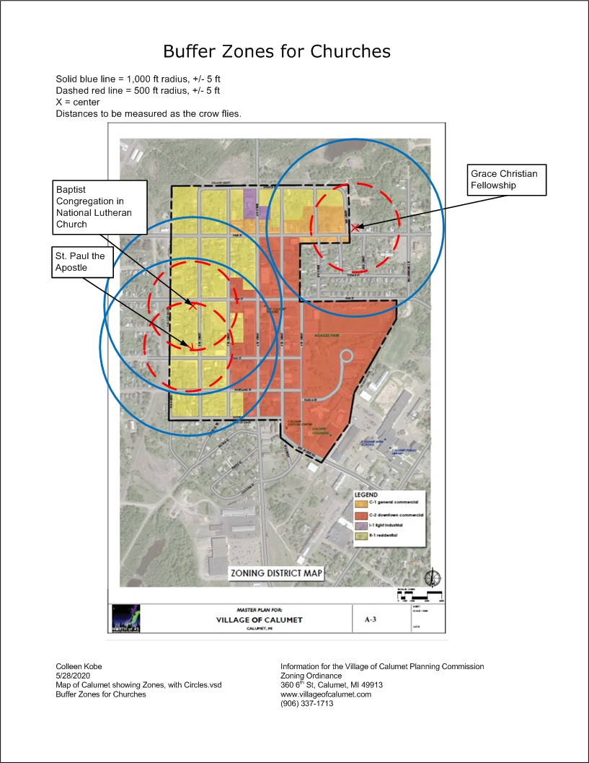
Figure 1: Village of Calumet: Buffer Zones around Churches
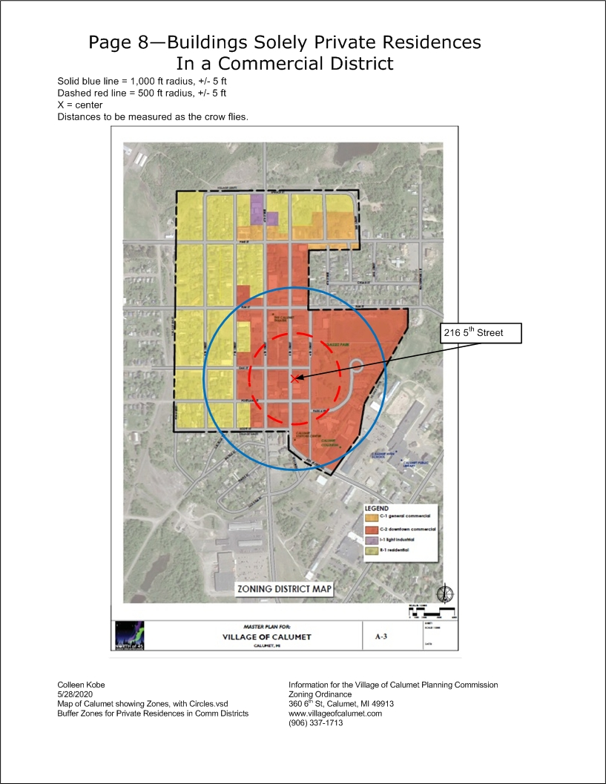
Figure 2: Village of Calumet: Buffer Zones around buildings solely used as a single-family residence in a Commercial District
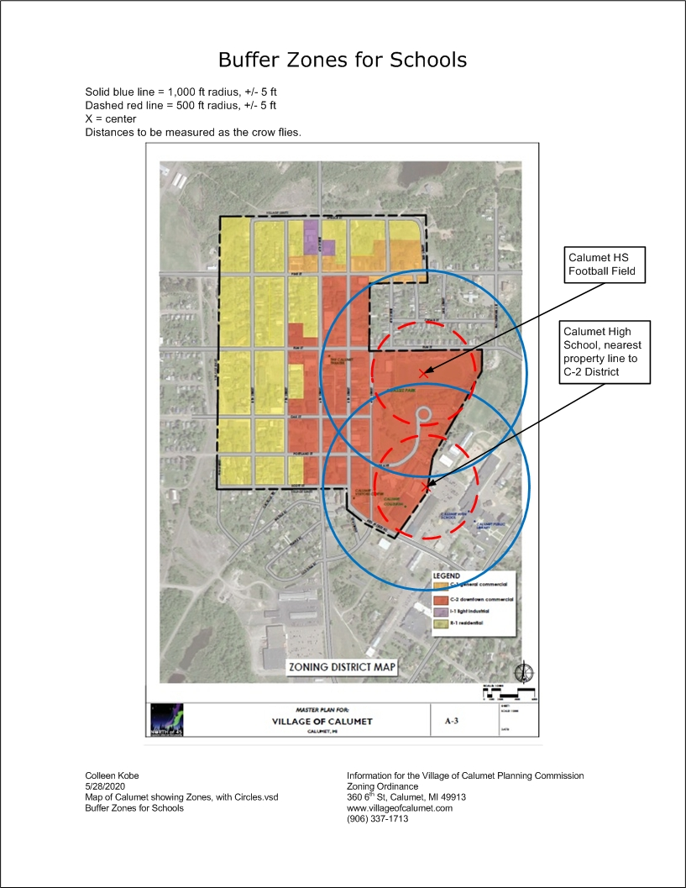
Figure 3: Village of Calumet: Buffer Zones Measured from the Borders of Calumet School Property
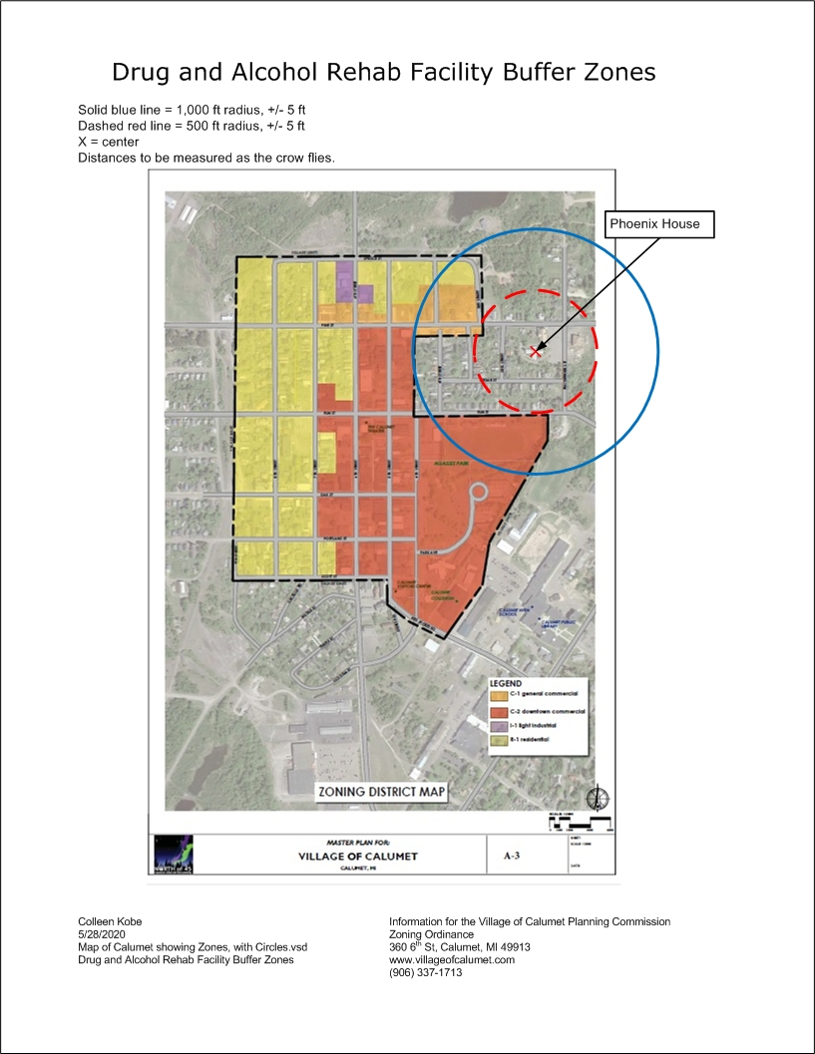
Figure 4: Village of Calumet: Buffer Zones around Drug and Alcohol Rehab Facilities
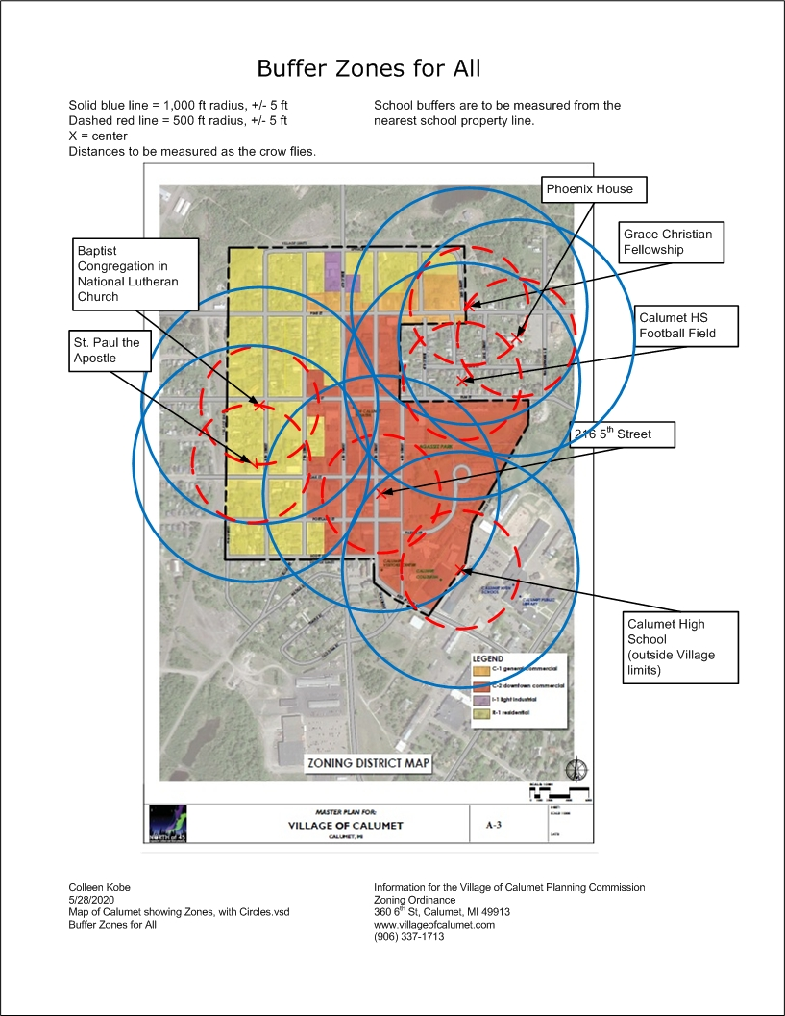
Figure 5: Village of Calumet: Buffer Zones around Churches, Schools, Rehab Facilities, and Private Residences in a Commercial District

Validity
Should any Section or provision of this Ordinance be declared by a court of competent jurisdiction to be invalid, such decision shall not affect the validity of the Ordinance as a whole or any part thereof other than the part so declared to be invalid.

Date of passage
This Ordinance shall be in full force and effect thirty (30) days from and after the passage, approval and publication, as provided by law.
PASSED AND APPROVED this __________ day of ___________________, 20_______.
Village of Calumet, Houghton County, Michigan
 |  | Village President
ATTEST:
Village Clerk
Recommended by:
The Village of Calumet Planning Commission
Date |  | Chair

See next page for Date of Effect.

Date of Effect
DATE OF EFFECT this __________ day of ___________________, 20_______.
Village of Calumet, Houghton County, Michigan
 |  | Village President
ATTEST:
Village Clerk
Recommended by:
The Village of Calumet Planning Commission
Date |  | Chair

